**Sprint Update Document**

**Cubic File Management System v1.0**

**Developer: Jayanta Acharjee**

Sprint 1:

Start Date: 14th September,2020

End Date: 23rd September,2020

Completed Work Items: 4

Product Backlog: N/A

Work Item ID:

1. NF001: Main Menu and Sub Menu options to be configured.
2. NF002: Java File Management System Console App Welcome Page
3. NF003: Logic for Adding a file
4. NF004: Logic to View list of files available

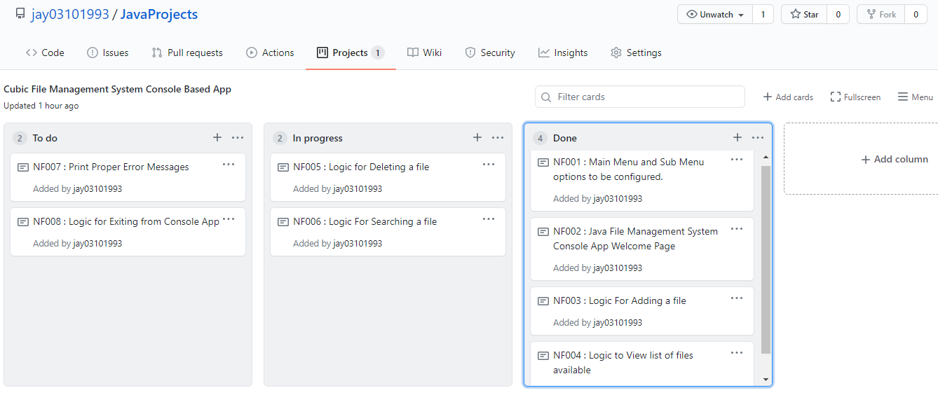

(continued)

Sprint 2:

Start Date: 24th September,2020

End Date: 2nd October,2020

Completed Work Items: 4

Product Backlog: N/A

Work Item ID:

1. NF005: Logic for Deleting a file
2. NF006: Logic for Searching a file
3. NF007: Print Proper Error Messages
4. NF008: Logic for Exiting from Console App

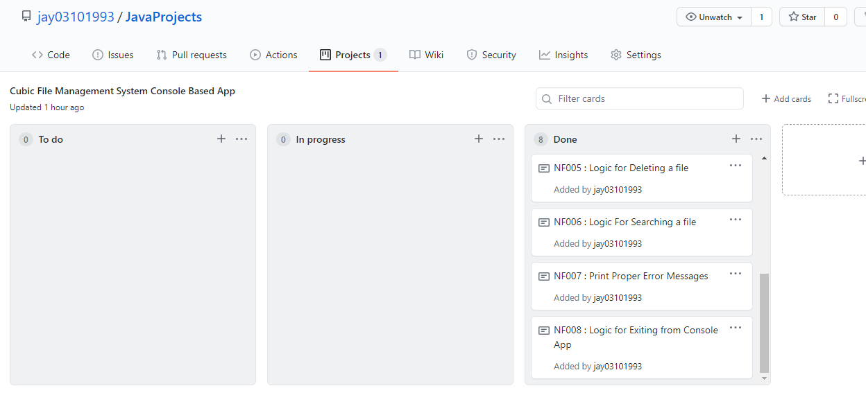

Final Verification and Product Release: 4th October,2020